Professional Reference Collector Guide

  - A step‑by‑step system for gathering accurate, recruiter‑ready reference information using Google Forms

Contents
1. Overview 1
2. Build the Google Form 2
Step 1 — Start the Form 2
Step 2 — Add the Required Questions 2
3. Configure Professional Settings 3
4. Connect the Form to Your “Database” (Google Sheets) 4
5. Sending the Request 4
6. Tips for Maintaining a Professional Reference System 4
7. Optional Enhancements 5
How is the data secured? 5
1. The Technical Layer (Encryption) 5
2. Access Controls 5
3. Compliance (HIPAA & GDPR) 5
4. Pro-Tips for Security 5

1. Overview
This guide walks you through building a professional, automated reference-collection system using Google Forms. It ensures your references provide accurate, up-to-date information — the exact details recruiters expect in high-stakes fields like Cybersecurity.

2. Build the Google Form
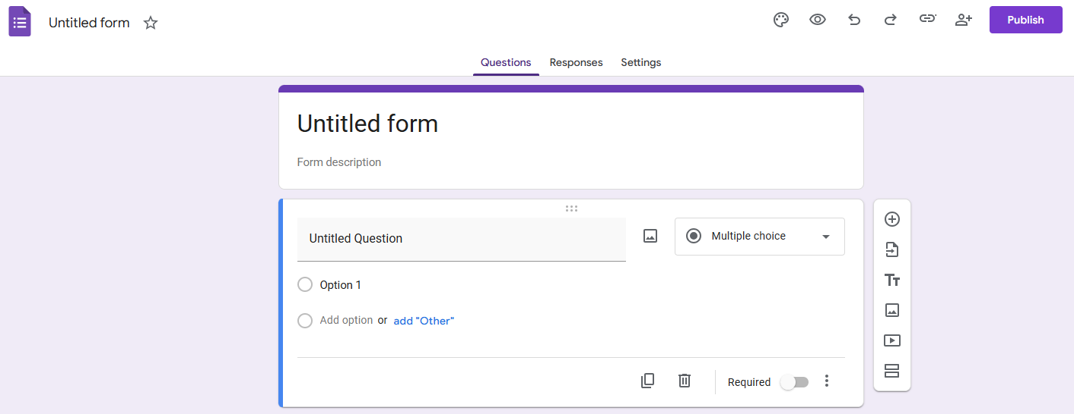

Step 1 — Start the Form
Go to forms.google.com
Select Blank
Title the form:
Professional Reference Update – [Your Name]

Step 2 — Add the Required Questions
Use these fields to ensure you collect recruiter-ready data:
Required Fields
Full Name — Short Answer
Current Job Title — Short Answer
Current Company — Short Answer
Preferred Email — Short Answer
Best Phone Number — Short Answer
Our Professional Overlap — Paragraph
Suggested wording:
“What was our relationship (e.g., Direct Supervisor, Peer), and what years did we work together?”
Preferred Contact Method — Multiple Choice
Options: Email, Text, Phone Call

3. Configure Professional Settings
[Graphic Placeholder: Google Forms Settings Panel]
Enable Notifications
Go to the Responses tab
Click the three dots (⋮)
Select Get email notifications for new responses
Add a Professional Confirmation Message
Navigate to:
Settings → Presentation → Confirmation message → Edit
Paste this message:
“Thank you! Your information has been updated. I’ll reach out with a heads-up if a recruiter mentions they'll be contacting you. If you ever need a reciprocal reference, please don't hesitate to ask!”

4. Connect the Form to Your “Database” (Google Sheets)
[Graphic Placeholder: Link to Sheets Button]
Go to the Responses tab
Click Link to Sheets
A spreadsheet will be created automatically
This becomes your master reference list
As people like Grant Gilliam or Glynn Baron submit updates, their information appears instantly.

5. Sending the Request
[Graphic Placeholder: Google Forms Send Button]
When ready, click Send, copy the link, and share it with your references using this message:
Subject: Quick favor / Reference update

Hi [Name],

I hope you’re doing well! I’m currently updating my professional reference list for some Cybersecurity roles I’m pursuing.

Would you be comfortable serving as a reference for me? If so, could you take 60 seconds to drop your current details into this link? I want to make sure I have your most recent title and contact info exactly right before I share it with hiring managers.

[Link to your Google Form]

Thanks for the help!
[Your Name]

6. Tips for Maintaining a Professional Reference System
Update your list every 6–12 months
Track:
Relationship
Years worked together
Strengths they can speak to
Offer reciprocal references
Store the Google Sheet in a labeled folder:
/Career Docs/References/2026

7. Optional Enhancements
Add a photo or logo to the form header
Use Google Form themes for a polished look
Add a timestamp column in Sheets
Create a pivot table to categorize references by role or company

How is the data secured?
Here is the breakdown of how your data is protected:

1. The Technical Layer (Encryption)
- In Transit: When someone hits "Submit," the data travels from their device to Google's servers via HTTPS/TLS encryption. This prevents "man-in-the-middle" attacks where someone might try to sniff the data on public Wi-Fi.
- At Rest: Once the data is sitting in Google’s cloud, it is encrypted using AES-256, which is the industry gold standard.

2. Access Controls
The biggest security risk with Google Forms isn't usually a "hack"—it’s accidental oversharing.
- Response Sheets: Your data usually lives in a connected Google Sheet. If you accidentally set that Sheet to "Anyone with the link can view," your data is effectively public.
- Domain Restricting: If you use Google Workspace (for business or school), you can toggle a setting so that only people in your organization can even open the form.

3. Compliance (HIPAA & GDPR)
- GDPR: Google Forms is generally compliant with European data privacy laws, provided you (the creator) handle the data responsibly.
- HIPAA (Healthcare): It's a "yes, but..." situation. Google Forms can be HIPAA compliant, but only if you have a paid Google Workspace account and have signed a Business Associate Agreement (BAA) with Google. Using a free "@gmail.com" account for medical data is a major compliance violation.

4. Pro-Tips for Security
- Enable 2FA: Since your Google account is the "key" to all your form data, having Two-Factor Authentication enabled is your best defense against unauthorized access.
- Limit "Editors": Don't give "Editor" access to the form to everyone. More editors mean more people who could accidentally change the sharing settings.
- Response Validation: You can set up "Password Protection" using a section break and response validation (making the form require a specific code before showing the questions), though this is more of a hurdle than a true security wall.



